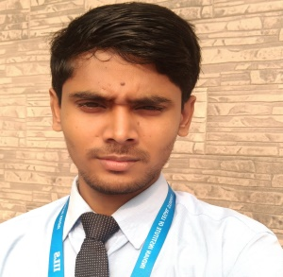
SABIR ALI
EMAIL-alisabir_20@rediffmail.com

MR. SABIR ALI IS CURRENTLY WORKING AS A LIBRARIAN AT INDIAN INSTITUTE OF LEGAL STUDIES, SILIGURI. HE COMPLETED HIS B.A. IN ENGLISH (HONS.) FROM ACHARYA PRAFULLA CHANDRA ROY GOVERNMENT COLLEGE, UNIVERSITY OF NORTH BENGAL IN 2015 AND HIS MASTER OF LIBRARY & INFORMATION SCIENCE IN 2018 FROM THE SAME UNIVERSITY WITH FIRST CLASS AND ALSO DONE BACHELOR OF LIBRARY AND INFORMATION SCIENCE FROM THE SAME UNIVERSITY. HE IS ALSO QUALIFIED IN UGC-NET EXAMINATION IN 2019.

HEHAD WORKED AS AN INTERN AT UNIVERSITY OF NORTH BENGAL AND ALSO WORKED AS AN ASSISTANT LIBRARIAN AT OLIVIA ENLIGHTENED ENGLISH SCHOOL, BIDHANNAGAR, SILIGURI.

