CLINICAL LEGAL CLASSES 2018
With the high aim of delivering the pragmatic approach to the study of law our Institute, Indian Institute of Legal studies has initiated with the special program named Clinical Legal Classes. The program is designed to impart practical knowledge to our students. These classes are specially designed for a practical knowledge and clear perception of law. It will groom our students for a concrete future. It will enhance the thought process, advocacy skills and professional ethics to the fullest. The importance and significance of Clinical Legal Classes is manifold and far reaching. The prime goal is to assist a law student in becoming a better legal thinker, planner and practitioner and to make him adept in his profession. The clinical process is a blueprint for professional growth. The students shall be groomed by eminent dignitaries. The interactive sessions with the dignitaries of such high repute and stature shall enlighten the young minds with esteem intellect. With this hope and aspirations the Indian Institute of Legal Studies has scheduled the clinical legal classes inviting distinguished dignitaries for every month.
April, 2018:
For the month of April, 2018 the schedule is from 23rd of April, 2018 to 27th of April, 2018
The Classes will be conducted by Hon’ble Dr. Justice Manjula Chellur, Former Chief Justice, Bombay High Court.

The names of the three Advocates of Karnataka High Court:
1. Adv. Sudha S. N.
2. Adv. Beena Devaraj
3. Adv. Geetha Devi M. Papanna

[About Hon’ble Dr. Justice Manjula Chellur
Hon’ble Dr. Justice Manjula Chellur was the first woman advocate in Bellary, and then, the first woman judge of the Karnataka High Court. She was appointed as the Chief Justice of the Kerala High Court in 2012, and thereafter, transferred to Calcutta High Court. Ma’am took charge of the Bombay High Court as its Chief justice in August 2016 and retired on 5th December, 2018. During her tenure Ma’am has always dedicated herself to the utmost welfare of the citizens of India.]
Hon'ble Madam Justice Manjula Chellur along with a team of three advocates (all the advocates having an experience of over and above 25 years of practice in the Karnataka High Court) shall be delivering special lectures. The ambit of the clinical legal classes for the month of April includes Constitutional Law, Jurisprudence, Alternative Dispute Resolution, Family Law, Suits for recovery of money, Labour Laws and property Rights. The program of five days rigorous clinical legal classes also includes classes on Development of communication skills, Group exercises, Presentations by the Students on Case Laws, Moot Courts and Open Discussions. The students will be divided into small groups for such exercises to give special attention to each student.
These Clinical Professors will have different approaches to the role of theory in the development of professional skills and values. Clinicians will assign materials that describe a particular theory of the skill or value early in the course and then require the students to emulate on that theory. Typically, clinicians will require students to develop plans for some or all of the following skills: interviewing clients and/or witnesses, counselling clients, drafting pleadings, engaging in negotiation or mediation, preparing for a trial or hearing or developing alternative solutions to help the client.
May, 2018:

For the month of May, 2018 the schedule is from 14th of May to 18th of May, 2018

For the Month of May, 2018 Indian Institute of Legal Studies organizes Clinical Legal Classes by Hon’ble Mr. Justice Asok Kumar Ganguly, Former Judge, The Supreme Court of India on the subjects of Constitutional Law and Human Rights Practice.
These Clinical Legal Classes will be delivered for the students of 3 years LL.B. Semester II and 5 years LL.B. Semester IV on the subject of Constitutional Law and for the students of LL.B. 3 years Semester VI and B.A./B.B.A/B.COM LL.B. 5 years Semester X on 17th & 18th of May, 2018 on the subject of Human Rights Law & Practice.
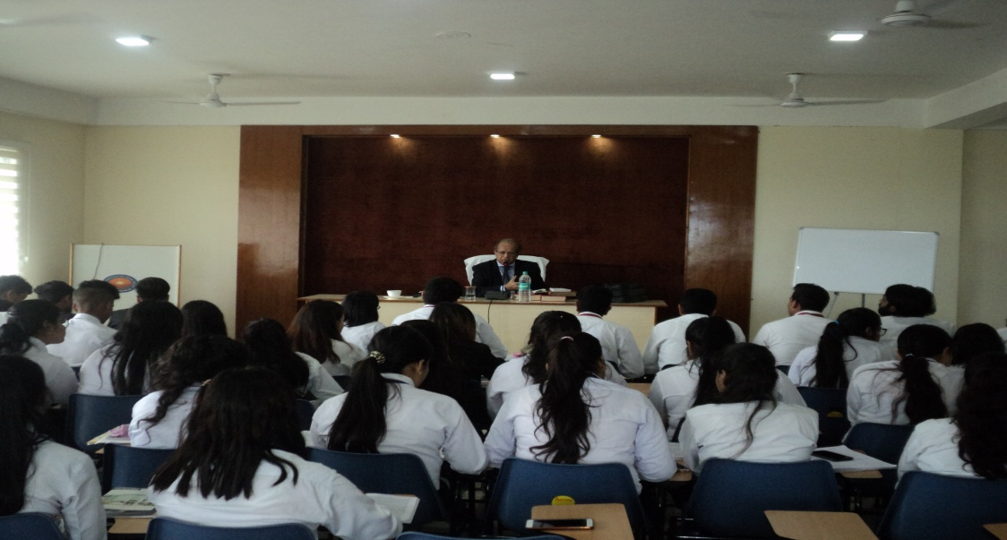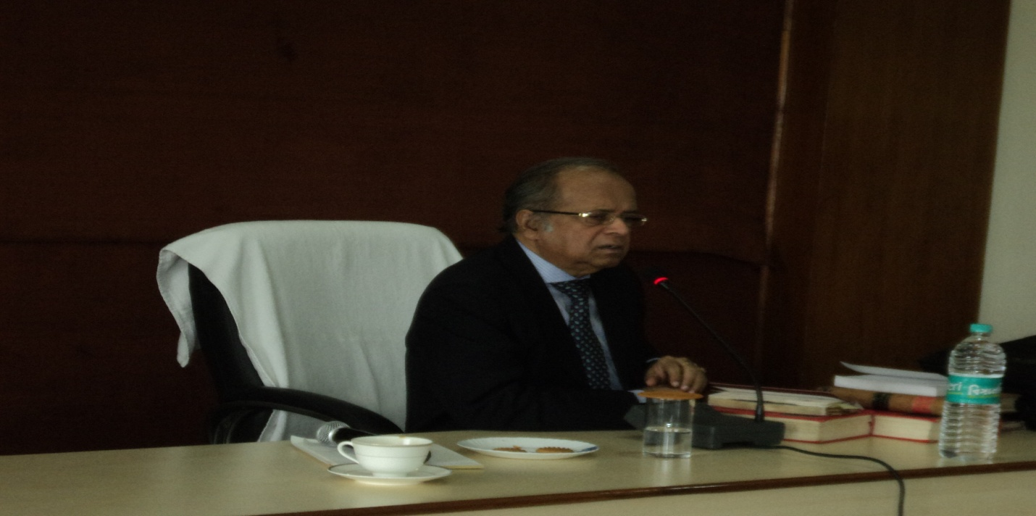
[About Hon’ble Mr. Justice Asok Kumar Ganguly]
Hon’ble Mr. Justice Asok Kumar Ganguly started his practice in Calcutta High Court in the year 1972. During his tenure he had been appointed as the Judge of the Calcutta High Court and Patna High court. Hon’ble Mr. Justice Asok Kumar Ganguly became the senior most puisne Judge of the Calcutta High Court in March 2005. He functioned twice as "Acting Chief Justice of Calcutta High Court". Later he was transferred to Orissa High Court where he joined as the senior most puisne Judge on 21 April, 2006. On 2nd March, 2007 he took oath as Chief Justice of Orissa. He joined Madras High Court as Chief Justice on 19 May, 2008. Later he was transferred to Supreme Court of India where he joined on 17 December, 2008 and remained in the apex court for more than 3 years. He retired on 3rd February 2012. He also went on to be the Chairperson of the West Bengal Human Rights commission, where his role was highly appreciated.

DECEMBER, 2018:

For the month of May, 2018 the schedule is from 7th of December to 9th of December, 2018
Indian Institute of Legal Studies is organizing Clinical Legal Classes for the students of B.A./B.B.A/ B.COM 5 Years LL.B. Semester IX and 3 Years LL.B. Semester V to give them the pragmatic and practical approach towards the theoretical subjects of Law. It is basically to assist the students in understanding the practical nuances of the subjects. The subjects such as Civil Laws, Property Laws and Matrimonial Laws shall be dealt with along with the fundamental concepts of the jurisprudential aspects of Constitutional law.
The said Clinical Legal Classes shall be provided by Ms. Geetha Devi MP and Ms. Sudha SN, the Senior Advocates of Karnataka High Court on 7th, 8th and 9th of December, 2018.
