2ND YOUTH PARLIAMENT, 2017

Indian Institute of Legal Studies takes immense pleasure in organizing its Second Edition of Youth Parliament to be held on 25th-26thNovember 2017.

In a world like this where today’s youth, with raging ambition want to bring about a change in the society, this event would provide them a platform to achieve a greater understanding not only of the Parliament, but enhance the skills that a student would need throughout his career. As 26th November marks Law Day, IILS takes this opportunity to make students aware about how Parliamentary Procedure and passing of an Act takes place.
School Students of Class XI and XII and college Student of first year of any educational institution in and around Siliguri can participate in the second edition of Youth Parliament.
SCHEDULE

 |  |  | DATE | EVENT
 |  |  | Last date of registration | 15th November’17
 |  |  | Last date of submission of soft copy | 20th November’17
 |  |  | of writing
 |  |  | Inauguration/ registration and 1st Session of Parliamentary Proceedings | 25th November’17
 |  |  | 2nd Session of Parliamentary Proceedings | 26th November,17
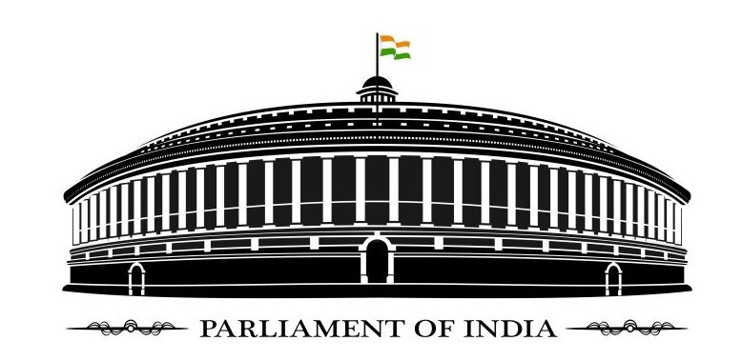
AGENDA

- Right to Privacy: Five Bills yet no law.
- Triple Talaq is Unconstitutional and void- it’s time to legislate on it.

SUBMISSION BY PARTICIPANTS

Every participant is required to send a piece of their writing in form of article, essay or bill on the above given topic by 20th November, 2017 at debatesociety.iils@gmail.com The participant need to write both for and against the topic.

All research, writing and editing must be solely the product of the members of the participating team. Persons other than the members of the participating team are not permitted to research on the Statement of Problem of the competition or to provide any other kind of assistance to the participating members. The word limit of the specimen should not be more than 1500 words.
A draw of lots will be held on the day of the event

RULES AND REGULATION

1. ELIGIBILITY

Senior Secondary students of 11th and 12th standard and the college Student of First Year

2. LANGUAGE

The Competition will be a bilingual competition conducted both in English & Hindi language

3. REGISTRATION

Registration to the competition is open to the entire student. A minimum of one and a maximum of four can participate from a concerned institution. The Student have to participate individually. There is no registration fee.

4. DRESS CODE

The participants are expected to be dressed in Indian/western Formals.

- AWARDS AND CERTIFICATES

  - “Best Parliamentarian ”– Rs. 7000/-

  - “High Commendation”- Rs. 5000/-

  - “Best Speaker” - Rs. 3000/-

  - “Best Scribe” - Rs. 3000/-

  - “Special Mention” -Rs. 1000/-

  - “Verbal Mention” ” -Rs. 1000/-

In addition , all the participants will be awarded with participation certificate which will be issued at the end of the event.

- QUERIESANDCLARIFICATION
The Participants are free to contact

FACULTY CO-ORDINATOR
    - Ms.JayatiKhagra, Asst. Prof. of Law, IILS - +91 7602023037, +91 9775509999

STUDENT CO-ORDINATOR

- AayushiAgarwal - +91 7679226407
- Himanshu Kumar Singh- +91 7501404284
- Mohan Hembram- +91 9163812485
- Binesh Kumar Prasad- +91 7407264895

