SUBMISSION GUIDELINES
All submissions must contain some novel analysis comprised of the author(s)’ views and which adds to the existing literature on the subject, but must not be a simple descriptive/informative piece or a compilation of content from different sources.
We expect authors to comprehensively engage with the foundation of the chosen topic, aiming to underline its relevance for present times.
The Editorial Board expects authors to adhere to an academically accepted style of legal writing. Hence, all submissions must contain an introduction, main body containing the primary argument, conclusion and suggestions (if any).
All decisions of the Editorial Board would be final and may not be subject to further review. We expect authors to make suitable changes as suggested by the Editorial Board before final acceptance. All submissions are subject to editorial review; submission does not guarantee publication. (Ref. Copyright and Editorial policy on website)

All contributions must be submitted by email to quest.iilsindia@gmail.com.
- Email Subject: eg., QUEST Volume XII, Issue 4 – [Submission Category]
- Author Details: Include full name, course, semester, title, category, and contact details.
- File Format: Submit written contributions in both editable Word and PDF formats. Visual contributions must be submitted in suitable high-resolution formats, with a brief description wherever required.
- Authorship: Submissions are invited from the enrolled students of the institute. Co-authorship is permissible up to 2(two) authors only for the category of ‘Empirical and Field Studies’ For other categories, co-authorship is not permitted.
- Originality: Authors are requested to ensure that the manuscript submitted is original. The work has to be fully referenced, and all authors cited should be accurately represented. The author(s) bear sole responsibility for the accuracy of facts, opinions or views stated in the submitted paper. In case of any gross plagiarism found in the contents of the submitted paper, the manuscript shall be dealt as per plagiarism policy as per Quest.
- Deadline: The last date for registration will be mentioned in the notice, the synopsis must be submitted within 2 days of registration. Submissions sent after the deadline will not be considered for publication. The author may request for the extension of the submission date by duly providing reasonable justifications and approval of extension is subjected to the discretion of the Editorial Board.
- Footnotes: Legal scholarly submissions must follow the Bluebook, 21st Edition. Footnotes must be in 10-point font with single spacing. (Download from the college website: Quest Editorial Board)
- Abstract and Keywords: Where applicable, include an abstract of 150–200 words and five keywords.
- Figures, Tables and Images: Number and caption consecutively, for example, Figure 1: Survey Findings, Table 1: Respondent Profile, and Image 1: Fieldwork Documentation. Acknowledge sources wherever applicable and refer to each figure, table, or image in the text with a brief explanation.
- Image Quality and Resolution: Figures, photographs, illustrations, charts and other visual materials shall be submitted in sufficiently high resolution for both online and print publication. Images should preferably have a resolution of 300 DPI or higher and, wherever technically applicable, a minimum dimension of 1000 pixels in width or height. For photographs intended for print publication, a larger image is preferred. Images must not be stretched, squeezed, distorted, excessively compressed or pixelated. Preferred formats include JPEG, PNG, TIFF, PDF and EPS, depending upon the nature of the material.
- Author Photograph: Where an author photograph is required, it shall ordinarily be provided in the dimensions of 3 cm width × 4 cm height. The photograph must be clear and appropriately cropped and shall not be disproportionately stretched or compressed.
- Word limit: All the word limits mentioned below are inclusive of footnotes. Please note that the word limits should be strictly enforced.
- Formatting: Please avoid underlining or bolding phrases and sentences for emphasis.
Element | Requirement
 | Font | Size | Spacing | Alignment
Article Title | Times New Roman | 16 pt, Bold | 1.5 | Centre
Author Name | Times New Roman | 12 pt, Bold | 1.5 | Centre
Abstract | Times New Roman | 12 pt, Italic | 1.5 | Justified
Main Heading | Times New Roman | 14 pt, Bold | 1.5 | Left
Sub-Heading | Times New Roman | 12 pt, Bold | 1.5 | Left
Body Text | Times New Roman | 12 pt | 1.5 | Justified
Footnotes | Times New Roman | 10 pt | Single | Justified
Page layout | A4 size with 1inch margins or Template provided by QUEST

QUERIES AND CLARIFICATIONS

For any query regarding the submission process, formatting, category, citation, originality or publication requirements, authors may contact their respective assigned editors. The WhatsApp group (see,. notification circular provided on the college Notice Board to join the group) is for announcements and communication only. All contributions must be submitted by email.

CATEGORIES OF CONTRIBUTION:
The following categories of publication will be accepted for publication: -

PART A — SCHOLARLY CONTRIBUTIONS
- SHORT ARTICLES
Short Articles shall provide concise scholarly analysis of legal, socio-legal, interdisciplinary or contemporary issues. The word limit shall be 1,500–3,499 words, inclusive of footnotes.
- BLOGS
This section shall address relevant and contemporary legal or socio-legal issues and should reflect present social needs, emerging challenges and public concerns. The prescribed word limit shall be 1,000–1,500 words.
- CASE NOTES
A Case Note would analyse a recent judgment or landmark decision of Indian courts, informing on the background of the matter and substantive implications for future adjudication. The word limit for case note is 1500- 4000 words. (Ref. below Format)
- LEGISLATIVE COMMENTS
Legislative Comment would analyse the legislation or bill before the Parliament or any state legislature, facilitating a cross-jurisdictional comparative analysis and suggesting improvements. The word limit for the review is 1500- 3000 words.
- BOOK REVIEWS
A Book Review shall critically examine a legal or interdisciplinary book by presenting its principal arguments, contribution, methodology and relevance. The word limit shall be 1,500–4,000 words. The review should provide critical analysis rather than merely summarising the contents of the book.
- NORMATIVE LAW ARTICLES
The Quest will explore the opinion of students relating to the specific legislations involved in the theme of the Journal. It seeks to bring out a student ‘s view on how a particular Legislation or Legislative Provision should have been drafted to bring out clarity into the law. The article must first state briefly the Legislation/Legislative provision and then suggest what changes can be adopted in it. Should you have reason to believe that the particular legislation requires some amendments, you are welcome to draft and/or amend the provisions or you can re-draft the entire law if so, be the requirement. Arguments must be logical and can take into account aspects such as the Sociological, Political, and Economic Implications of law. The word limit shall not exceed 5,000 words.

PART B — RESEARCH AND PRACTICAL WORK
- EMPIRICAL STUDIES

This section shall provide a platform for original empirical and field-based research. Submissions may include questionnaire-based studies, surveys, interviews, awareness studies, socio-legal research, institutional studies, community studies, environmental studies and other field-based research. The submission should clearly identify the research objective, methodology, sample or participants, data collection method, findings, analysis and conclusion. Tables, graphs, charts and photographs may be included where relevant. (Ref. below general format) The suggested word limit shall be 1,500–3,500 words/ Maximum 5-7 pages. Authors must accurately represent their data, and fabrication, manipulation or misrepresentation of data shall constitute grounds for rejection.

PART C — CREATIVE AND VISUAL WORK
- POEMS AND LITERARY WORKS

Students may submit original poems and other literary works relating to law, justice, society, human rights, environment, education or other themes relevant to the Quest. The work must be original and must not infringe the copyright or other rights of any third party.
- ARTWORKS

Students may submit original sketches, paintings, portraits, illustrations, landscapes and other forms of visual art. Each submission shall contain the title of the artwork and the name of the artist, together with a brief description where appropriate. The artwork must be original or lawfully used with the necessary permission.
- PHOTOGRAPHY

Students may submit original photographs relating to law, society, environment, culture, education, community, campus activities and other subjects relevant to the Quest. Each photograph should, where applicable, contain the title, photographer's name, date, location and a brief description or context. Photographs must be sufficiently clear and suitable for online and print publication.

PART D — ACHIEVEMENTS AND RECOGNITIONS
Submissions are invited for notable achievements in the following areas:
- Academic distinctions, scholarships, awards, and research recognitions.
- Moot court competitions, ADR competitions, debates, parliamentary competitions, Youth Parliament, and other recognised academic or institutional competitions.
- Sports, cultural, literary, and other competition achievements.
- Research publications in recognised or reputed journals and other academic platforms.
- Professional certifications, leadership recognitions, and other noteworthy accomplishments
Submissions should mention the event or institution, date, achievement, and supporting evidence wherever available. (Ref. below general Format)

PART E — EVENTS, SOCIAL WORK AND COMMUNITY ENGAGEMENT
Reports or reflections on seminars, conferences, workshops, guest lectures, legal aid camps, legal-awareness programmes, NGO activities, environmental initiatives, volunteering, and community outreach are welcome. Briefly state the purpose, activities undertaken, and outcomes.

SAMPLE OF FORMAT (To see more, check previously published journals at our website or printed Journals in the college Library)

STUDENT ACHIEVEMENTS AND RECOGNITIONS

Image

The submission should provide the student's name, programme or semester, nature of achievement, name of event or organisation, date, venue and a brief description.

- Title of the Report
- Author and Contribution Credentials
- Events or Achievements Details
- Experience of the event
- Photographs and Supporting Documents ( where available)

EMPIRICAL STUDY

- TITLE AND AUTHOR DETAILS
- ABSTRACT (150-200word limit including 5 Keywords)

Keywords: About five keywords separated by commas.

- INTRODUCTION

- RESEARCH OBJECTIVE AND HYPOTHESIS

- METHODOLOGY AND SAMPLING DESIGN

- DATA ANALYSIS AND EMPIRICAL FINDINGS :( Supporting Tables, statistical charts, questionnaire, and relevant field photographs are necessary.)
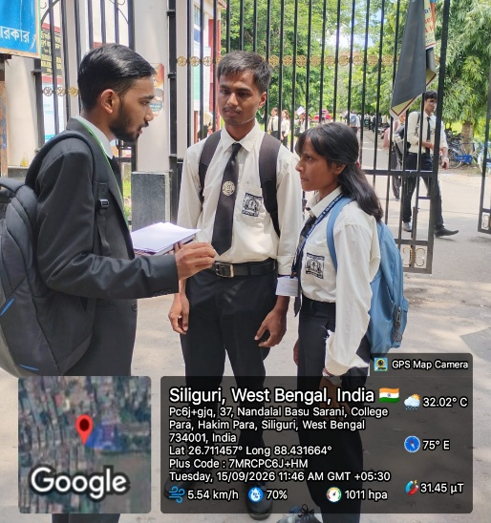

Image 1 : Field visit
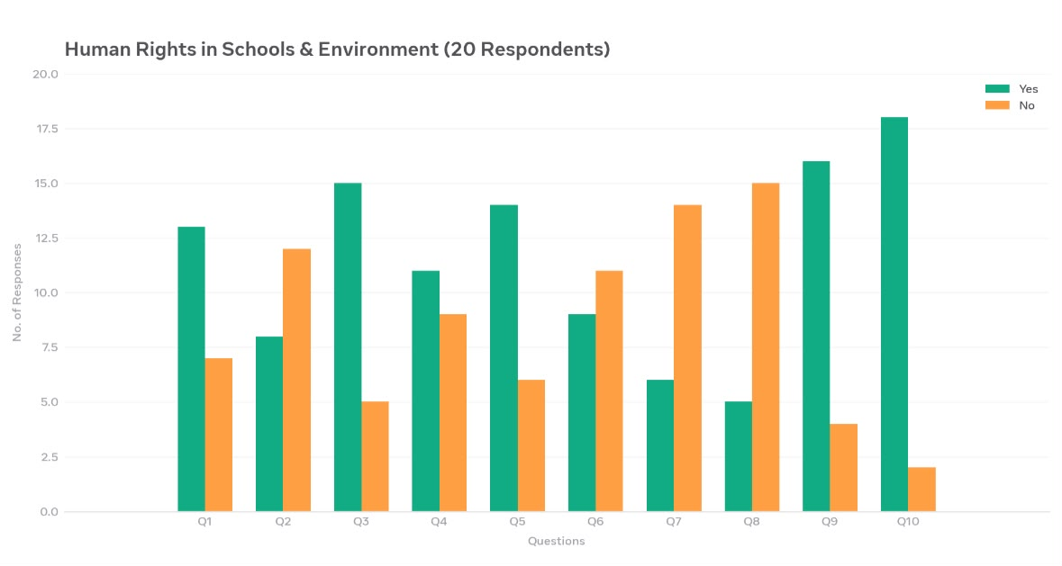
Figures/ Tables/Charts 1: The graph shows school students' responses. Awareness of constitutional provisions (Q7) is low, while demand for environmental subject (Q10) is high.

- CONCLUSION AND SUGGESTIONS/RECOMMENDATIONS
- REFERENCES

Name and Address of designated office/venue
Name and designation of contact person
Date of field visit
Target group/respondents

PHOTOGRAPHY
Image

The submission should provide the student's name, programme or semester, and a brief experience behind the picture. Visual methods should be of sufficient quality for publication, with 300 DPI or higher preferred where technically applicable.

CASE NOTE

- TITLE AND AUTHOR DETAILS
- ABSTRACT (100-200 words including 5 keywords)

Keywords: About five keywords separated by commas.

- INTRODUCTION
- CASE TITLE
- CITATION
- COURT
- DATE OF JUDGMENT
- BENCH
- MAJORITY
- PETITIONERS
- RESPONDENTS
- FACTS OF THE CASE
- ISSUES RAISED
- ARGUMENTS OF THE PARTIES
- JUDGMENT OF THE SUPREME COURT
- REASONING OF THE COURT
- CRITICAL ANALYSIS
- CONCLUSION

STUDENT ACHIEVEMENTS AND RECOGNITIONS EXAMPLE

ACHIEVEMENT IN MOOT COURT COMPETITION

National Moot Court Competition 2025–26

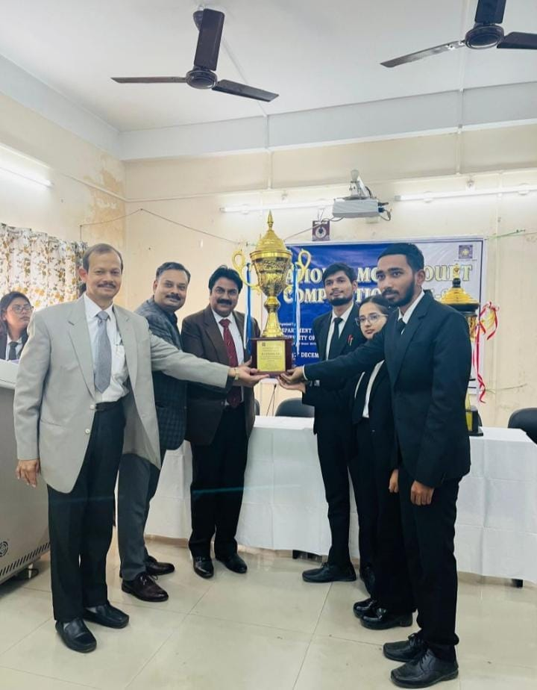
Image source: Department of Law, NBU

ACHIEVEMENT AT A GLANCE
Achievement: | Runner-Up, National Moot Court Competition 2025–26
Organiser/ Venue: | Department of Law, University of North Bengal, West Bengal
Date: | 11 and 12 December 2025
Final Round competing teams: | Rajendra Prasad National Law University, Prayagraj (Petitioner)  v.  Indian Institute of Legal Studies, Siliguri (Respondent)
Team Members: | - Piyush Mani Tripathi – First Speaker  - Surabi Chhetri – Second Speaker  - Chandan Sha – Researcher

ABOUT THE COMPETITION

The moot proposition concerned the constitutional and statutory rights of an individual to legal representation during police investigation and interrogation. It examined the extent to which an advocate may be present during interrogation, whether restrictions on such presence violate the right to consult and be defended by a legal practitioner, and the need for safeguards against custodial violence and coercive investigation. The problem required an analysis of constitutional guarantees, criminal procedure, principles of natural justice, and judicial precedents concerning advocates' presence during interrogation.

MY OBSERVATIONS AND EXPERIENCE

As a researcher, this competition taught me that legal research requires accuracy, authenticity, and continuous updating. Preparing a well-organised compendium is essential because it enables speakers to locate relevant authorities and support their arguments effectively. Researchers should examine not only landmark judgments but also the latest decisions, their dates, the strength of the bench, and the precise ratio decidendi. It is equally important to verify whether a judgment has been followed, distinguished, overruled, or referred to a larger bench.

For instance, Birendra Kumar Pandey v. Union of India, decided on 8 June 2023 by a two-judge bench, discussed permitting an advocate to remain within visible but beyond audible distance during interrogation while distinguishing Poolpandi v. Superintendent, Central Excise, a three-judge bench decision. This reinforced my belief that understanding judicial developments is as important as identifying relevant case laws.

My suggestion: Always verify judgments from authentic sources, read the relevant paragraphs rather than relying only on headnotes, check the current status of precedents, and prepare your compendium with the latest applicable authorities. Effective research is not simply about finding more cases; it is about finding the right authority and understanding its legal value.

