### PROMISSORY NOTE

### --------------------------------------------------

***Section 4 in The Negotiable Instruments Act, 1881***

*“Promissory note”. —A “promissory note” is an instrument in writing (not being a bank-note or a currency-note) containing an unconditional undertaking signed by the maker, to pay a certain sum of money only to, or to the order of, a certain person, or to the bearer of the instrument. Illustrations*

*A signs instruments in the following terms:*

1. *“I promise to pay B or order Rs. 500.”*
2. *‘‘I acknowledge myself to be indebted to B in Rs. 1,000, to be paid on demand, for value received.”*

***Definition***

***According to section 4 of Negotiable Instruments Act, 1881-*** A promissory note is an instrument in writing (not being a bank note or a currency note) containing an unconditional undertaking, signed by the maker to pay a certain sum of money to, or to the order of, a certain person or to the bearer of the instrument.  
A promissory note is a promise in writing by a person to pay a sum of money to a specified person or to his order.  
*Maker: The person who makes the promissory note and promises to pay is called the maker.  
Payee: The person to whom the payment is to be made is called the payee.*

### *Parties to a Promissory Note:*

To a promissory note, there are two parties viz. ‘Maker’ and the ‘Payee’.

#### (i) Maker or Drawer:

The maker is the person who makes and signs the note. He agrees to pay a certain amount on the date of maturity. *(borrower or debtor who promise to pay).*

#### (ii) Payee or Drawee:

The person in whose favour the promissory note is drawn is called payee. He is also known as drawee or promisee. Usually, the drawee is also the payee. In the above case, the payee is the person to whom the amount due on promissory note is payable. *(creditor who provides goods or services on credit or lends capital).*

Endorser: Drawee can endorse the instrument in favour of a third party. (Endorsee will receive the money).

***Illustration:***

As per format of promissory note, Hari Das is the drawer or maker who promises to pay Rs. 1,00,000 to Shri Vinay Pujari who is the drawee or payee. However, if this promissory note is transferred in favour of Ghanshyam Das, then Ghanshyam Das will be the payee.

***Types of Promissory Note***

1. On demand (has to be paid by the drawer whenever demanded by Drawee)
2. Usance (when specific date or specific Time period is mentioned).

### *Essentials or Characteristics of a Promissory Note:*

From the definition, it is clear that a promissory note must have the following essential elements.  
1. In writing - A promissory note must be in writing. Writing includes print and typewriting.  
2. Promise to pay - It must contain an undertaking or promise to pay. Thus, a mere acknowledgement of indebtedness is not sufficient. Notice that the use of the word promise is not essential to constitute an instrument as promissory note.

E.g.: - I promise to pay Rs 5000/- three months from this day to Mr Singh or bearer or order for value received. This is the correct form of promissory note as it clearly expresses the promise to pay.   
3. Unconditional - The promise to pay must not be conditional. Thus, instruments payable on performance or non- performance of a particular act or on the happening or non-happening of an event are not promissory notes.  
4. Signed by the Maker The promissory note must be signed by the maker, otherwise it is of no effect.  
5. Certain Parties - The instrument must point out with certainty the maker and the payee of the promissory note.  
6. Certain sum of money - The sum payable must be certain or capable of being made certain.  
7. Promise to pay money only - If the instrument contains a promise to pay something in addition money, it cannot be a promissory note.  
8. Number, place, date etc. - These are usually found in a promissory note but are not essential in law. If a promissory note does not bear a date, it is deemed to have been made when it was delivered.  
9. Instalments - It may be payable in instalments.  
10. It may be payable on demand or after a definite period - Payable 'on demand' means payable immediately or any time till it becomes time-barred. A demand promissory note becomes time barred on expiry of 3 years from the date it bears.  
11. It must be duly stamped under the Indian Stamp Act, 1940 - It means that the stamps of the requisite amount must have been affixed on the instrument. A promissory note, which is not so stamped, is a nullity.

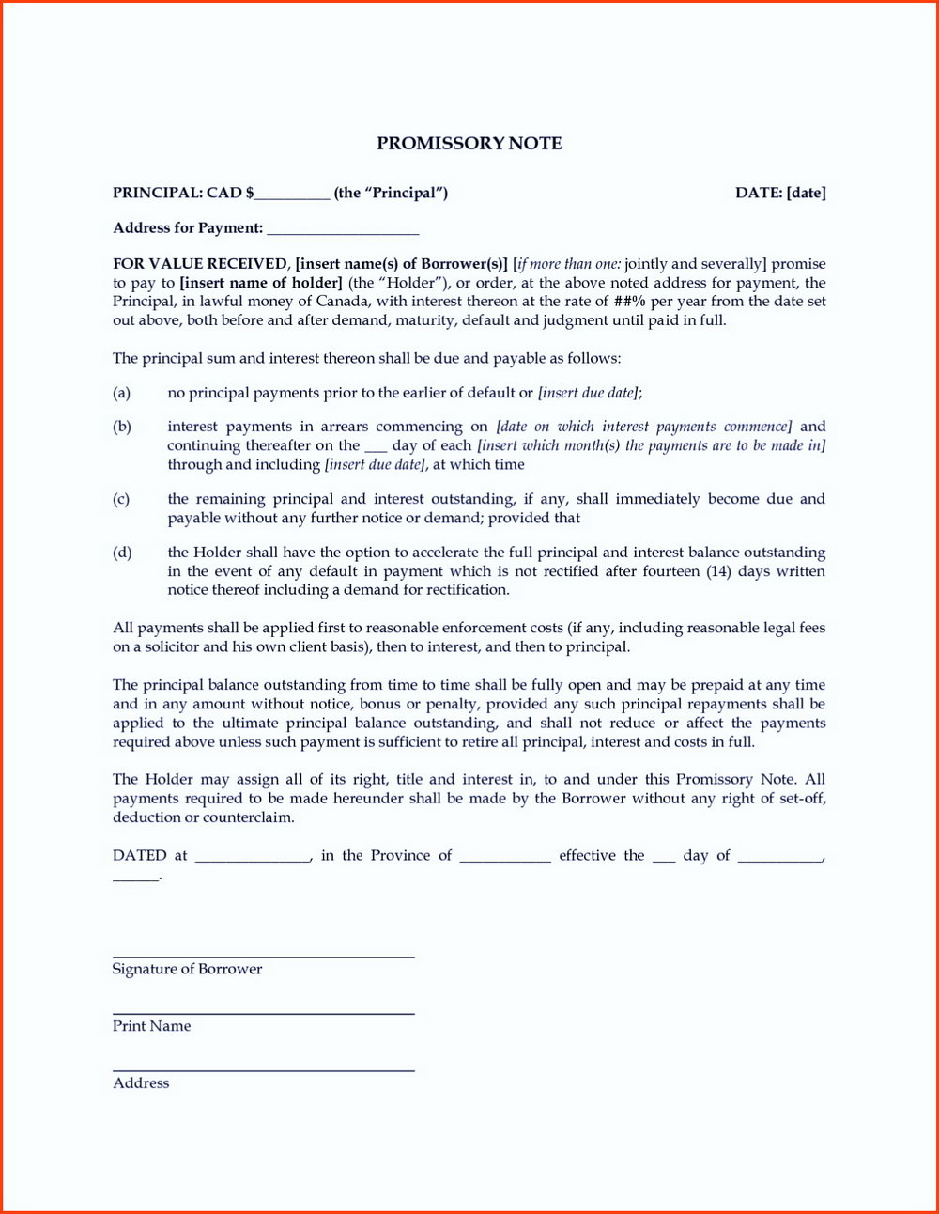

Figure 1

